Autonomous Maintenance Agent for Smart Factory Using Generative AI and Edge IIoT Systems
Conceptual Development Document
ITAI 3377
Group Members

Trevon Woods
Elizabeth Carrillo
Oscar Cortez
Luisleonardo Ortiz-Vazquez
Williane Yarro

April 25, 2026

Autonomous Maintenance Agent for Smart Factory Using Generative AI and Edge IIoT Systems

Introduction
- This capstone project presents a conceptual design for an autonomous maintenance agent for smart factory environments. The proposed system combines Generative AI, edge computing, Industrial Internet of Things devices, and autonomous decision making to improve predictive maintenance, reduce downtime, and support safer industrial operations. In this design, IIoT sensors collect real time data from industrial machines, edge devices process that data locally, and AI models identify abnormal patterns that may indicate equipment failure. A Generative AI assisted agent then provides maintenance recommendations, explains possible root causes, and supports faster response decisions. This project serves as a conceptual blueprint focusing on system architecture, data flow, cybersecurity, ethical considerations, and testing strategies for intelligent industrial automation.
- Modern industrial facilities depend on machines that must operate continuously, safely, and efficiently. When equipment fails unexpectedly, the result can be costly downtime, production delays, safety hazards, and expensive repairs. Many traditional maintenance systems are reactive, meaning action is taken only after a machine has already failed or obvious damage appears. Preventive maintenance reduces some risk, but scheduled inspections may still miss developing failures.
- Industry 4.0 emphasizes a few things that directly connect to the need for intelligent maintenance systems (Lu, 2017):
- Smart manufacturing
- Automation, IoT systems
- Data integration
- Improved operational efficiency
Project Proposal and Scope
- This project proposes an Autonomous Maintenance Agent that uses Generative AI, edge computing, and IIoT sensor data to detect problems earlier and support real time decision making. The system monitors industrial equipment such as motors, pumps, conveyor belts, compressors, and robotic arms through sensors collecting temperature, vibration, pressure, acoustic patterns, and power consumption data. Unlike conventional monitoring systems that only trigger alarms, the proposed system analyzes abnormal conditions, estimates risk, recommends corrective actions, and escalates alerts when necessary. Low risk conditions may require continued monitoring, while higher risk conditions may trigger immediate maintenance intervention or protective responses.
- The system’s safety logic is based on a general risk monitoring approach.
- The goal:
- Identify early warning signs
- Classify severity
- Escalate the response before a small issue becomes a major failure.
- In this project, abnormal machine data such as rising vibration, temperature changes, pressure irregularities, or increased power usage would be treated as warning indicators. The autonomous agent would then determine whether the issue should be monitored, flagged for maintenance, or escalated for immediate action. The goals of this project are to reduce downtime, improve safety, lower maintenance costs, and demonstrate how autonomous agents and Generative AI can strengthen industrial decision making.
System Architecture
- The selected use case focuses on predictive maintenance in a smart factory environment. The system is designed to monitor critical industrial equipment and identify early signs of mechanical or electrical failure before breakdowns occur. The equipment considered includes motors, pumps, compressors, conveyor systems, and robotic arms. These machines commonly produce measurable data patterns before failure. For example, a motor may begin to vibrate abnormally before a bearing fails. A compressor may show rising temperature or pressure irregularities before a major malfunction. A conveyor system may show increased power usage when mechanical resistance increases.
- The proposed system collects sensor data through IIoT devices and sends that information to an edge gateway for processing. Lightweight AI models analyze the data to identify abnormal behavior. When a possible issue is detected, the autonomous agent classifies the risk level and recommends an appropriate response.
- Risk Event Levels:
- Low risk events may simply be monitored
- Moderate risk events may trigger maintenance alerts
- Severe risk events may prompt immediate action.
- Expected Outcomes:
- reduced unplanned downtime
- lower maintenance costs
- improved equipment reliability
- stronger worker safety
- faster response to emerging faults
- increased cybersecurity awareness.
- The proposed architecture follows a layered model: sensors, edge gateway, AI models, autonomous agent, and maintenance response. The first layer consists of IIoT sensors attached to industrial equipment. These sensors gather real time information including vibration, temperature, pressure, sound, and power usage. Each provides a different indicator of machine health. The second layer is the edge computing layer. Rather than sending all raw data to the cloud, much of the processing occurs locally at the edge. This reduces latency, saves bandwidth, and enables faster decisions close to the equipment. Edge computing is especially useful in systems that require fast response, low latency, reduced bandwidth use, and stronger local processing capability (Liang et al., 2024). Conceptual tools could include Edge Impulse, TensorFlow Lite, Node RED, or edge devices such as Raspberry Pi or NVIDIA Jetson.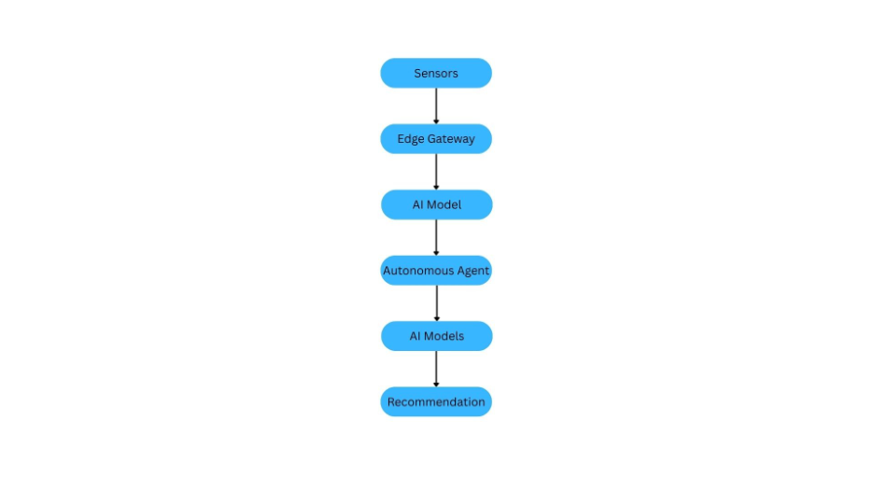
AI Model Development
- Using machine learning models such as anomaly detection, time series forecasting, or predictive maintenance classifiers, we will identify patterns associated with developing failures. Industrial AI supports smarter manufacturing by using data driven methods to improve machine health monitoring, production efficiency, and decision making (Lee et al., 2018). The autonomous agents will evaluate model outputs, apply rule-based safety logic, assign risk levels, and determine an appropriate response. For example, a mild anomaly may prompt continued monitoring, while multiple worsening signals may trigger immediate inspection recommendations. This architecture shifts maintenance from reactive response toward predictive and intelligent maintenance support.
- Generative AI Models:
- First, we could use a VAE to generate synthetic failure data. Because serious equipment failures may be rare or difficult to reproduce, synthetic examples can help train predictive models using simulated bearing wear, overheating events, or abnormal vibration patterns.
- Second, the use of an LLM like ChatGPT or Microsoft Copilot embedded in a Langchain agent to serve as a diagnostic assistant by translating model outputs into human readable recommendations. Instead of displaying only anomaly scores, the system may generate explanations such as “Possible bearing degradation detected. Rising vibration and temperature suggest increased friction. Inspection recommended within 24 hours.” This improves interpretability and supports maintenance decision making.
- The autonomous decision engine combines AI predictions with predefined safety rules. High impact actions such as shutdown recommendations remain governed by safeguards and, when necessary, human oversight. This approach makes the system more intelligent than conventional alarm-based maintenance systems by supporting prediction, explanation, and guided response.
Security and Ethical Considerations
- Security is a major concern in Edge and IIoT systems because connected industrial devices may be vulnerable to cyber threats. If attackers manipulate sensor data or gain access to control systems, operational and safety risks increase. The conceptual design includes encrypted communications, device authentication, role-based access control, and zero trust security principles. Every device and connection should be continuously verified rather than assumed trusted. The system should also monitor for cyber anomalies. If sensor readings behave inconsistently or appear impossible, the system should consider both equipment malfunction and potential data tampering.
- Ethical concerns include:
- Dependency on AI
- Model bias from synthetic data
- Determining responsibility for autonomous decisions.
- To reduce these risks, human oversight remains important. The system is intended to support expert decision making, not replace it. Safety safeguards include human override, continuous model validation, diverse training data, and system logs that support accountability and review.
Implementation and Testing Plans
- Implementation Phases:
- Phase 1:
- A pilot deployment focused on one equipment type such as industrial motors. Sensors would gather baseline operating data representing normal machine behavior.
- Phase 2:
- The second phase would involve training and testing predictive models capable of identifying abnormal patterns. Synthetic failure data could supplement training where needed.
- Phase 3:
- The third phase would conceptually deploy the model on an edge device where live sensor data could be processed and alerts generated in near real time.
- Phase 4:
- The fourth phase would integrate the autonomous agent to classify risks and recommend maintenance actions.
- Testing:
- Performance Testing
- Performance testing would evaluate detection accuracy, false positives, false negatives, and response times.
- Stress Testing
- Stress testing would simulate heavy data loads, sensor failures, communication disruptions, and resource limitations.
- Cybersecurity Testing
- Cybersecurity testing would include spoofed data, unauthorized access attempts, and abnormal network behavior.
- Safety Testing
- Safety testing would verify that recommendations remain appropriate under different risk conditions.
Challenges, Tradeoffs, and Lessons
- Tradeoffs must also be considered. More advanced models may improve accuracy but demand greater edge computing resources. Stronger security can add complexity or latency. Greater autonomy may increase efficiency but requires safety limits. Balancing these factors is part of practical system design.
- Overall, this project provides a conceptual blueprint for using Generative AI, edge computing, and IIoT systems to support predictive maintenance in a smart factory. The proposed agent would collect sensor data, analyze machine behavior, identify early signs of failure, and recommend maintenance actions before equipment breaks down. The design also includes cybersecurity protections, human oversight, and testing plans to make the system safer and more reliable. Although the project is conceptual and does not include coding, it shows how autonomous agents could improve industrial operations by reducing downtime, supporting maintenance teams, and improving safety.

References
Lee, J., Davari, H., Singh, J., & Pandhare, V. (2018). Industrial artificial intelligence for Industry 4.0-based manufacturing systems. Manufacturing Letters, 18, 20–23. https://doi.org/10.1016/j.mfglet.2018.09.002

Liang, S., Jin, S., & Chen, Y. (2024). A review of edge computing technology and its applications in power systems. Energies, 17(13), 3230. https://doi.org/10.3390/en17133230

Lu, Y. (2017). Industry 4.0: A survey on technologies, applications and open research issues. Journal of Industrial Information Integration, 6, 1–10. https://doi.org/10.1016/j.jii.2017.04.005

Shi, W., Cao, J., Zhang, Q., Li, Y., & Xu, L. (2016). Edge computing: Vision and challenges. IEEE Internet of Things Journal, 3(5), 637–646. https://doi.org/10.1109/JIOT.2016.2579198

